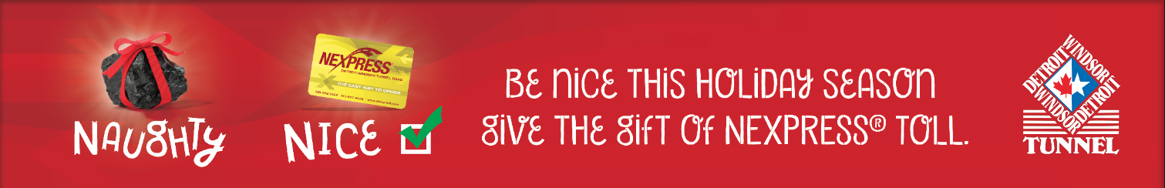
Gift of Toll Application

Mail-To Address

First Name: ________________ Last Name: __________________________ Phone #: _______________________
Address: ____________________________________ City: _____________________
Province/State: ________ Postal Code/ZIP: _______________

Billing Address
(Only if different than above)
First Name: ________________ Last Name: __________________________
Address: ____________________________________ City: _____________________
Province/State: ________ Postal Code/ZIP: _______________

Chose How Many: Windshield Tag ______

Continued on next page…

Payment Methods

The one-time payment of $106.60 can be made in U.S. or $135.20 Canadian dollars.
Keep a copy of this application for your records.

OPTION A — Payment by Credit Card
If paying by credit card – you can submit this form by:
Mail (address below), Fax: 313-567-2565, Email: customerservice@dwtunnel.com
Name as it appears on credit card: _____________________________
Visa/MasterCard Number: _______________________________________________
Expire Date (MM/YY): __________________
Currency of credit card: (Choose one) U.S. or Canadian _______________
OPTION B — Payment by Check or Money Order

Payable to the Detroit Windsor Tunnel LLC. Do not send cash.
Mail, along with this application to:
Detroit Windsor Tunnel Detroit Windsor Tunnel
100 East Jefferson or 555 Goyeau
Detroit, Michigan 48226 Windsor, Ontario N9A1H1

Thank you for using the Detroit Windsor Tunnel!

